`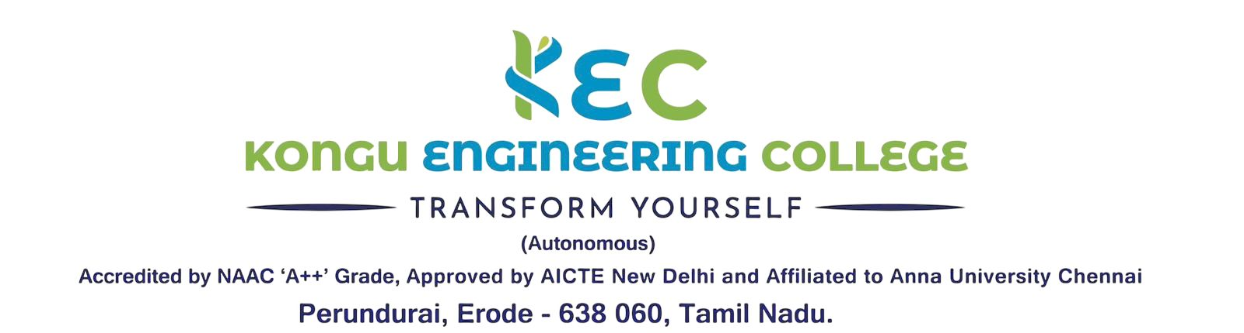  QR-12, Rev.0, 01.01.2025 | Doc. No:  KEC/EOMS/MDI/16
 | Rev. No | 00
INTERNAL QUALITY ASSURANCE CELL | Rev. Date | 01.01.2026
ACTION TAKEN FOR STUDENT FEEDBACK ABOUT THE FACULTY | Issue. No | 00

Academic Year: Semester:
Department: Date:
S. No. | Semester/ year | Name of the Course | Faculty | Cause Analysis  (by handling faculty) | Action Taken
1.
2.
3.
4.

Department IQAC Coordinator Head of the Department

